Automated test cases
Sample
Get Schema and ready into local DB
Insert with Sample values
Execute the function and Assert

Things to do:
Before we run the app,
Set Up - Get Schema from test02, all tables and all functions and put into local
1. Populate data for tables with DataMaker
Eg:
1. Patient info to check active patient function
Positive and negative cases

Steps to follow
1. GET SCHEMA - PENDING
2. INSERT WITH DUMMY DATA
3. EXECUTE FUNCTION
4. ASSERT THE RESULT
Projects
- HSVS.AutomatedTestCases.UnitTests
- HSVS.AutomatedTestCases.DataGeneration
- HSVS.AutomatedTestCases.BusinessLogic
- HSVS.AutomatedTestCases.Dao
- HSVS.AutomatedTestCases.Common
Unit Tests
Data Generation
Business Logic Layer
Common Utilities
Data Access Layer

Steps to run a sample
Step 1: CREATE TABLE

CREATE TABLE mysample
(
id integer,
name text,
mobile text
)
WITH (
OIDS=FALSE
);
ALTER TABLE mysample
OWNER TO postgres;

Step 2: CREATE FUNCTION
-- Function: getsampletabledatacount()

-- DROP FUNCTION getsampletabledatacount();

CREATE OR REPLACE FUNCTION getsampletabledatacount()
RETURNS integer AS
$BODY$
DECLARE

hospital_count integer := (SELECT count(*) FROM mysample);
BEGIN
return hospital_count;
-- CREATE TABLE mysample(id integer, name text, mobile text)
-- insert into mysample values(1, 'Praveen', '9999999999')
-- select * from mysample
-- select * from GetSampleTableDataCount()
END

$BODY$
LANGUAGE plpgsql VOLATILE
COST 100;
ALTER FUNCTION getsampletabledatacount()
OWNER TO postgres;
Step 3: Go to test cases and Run
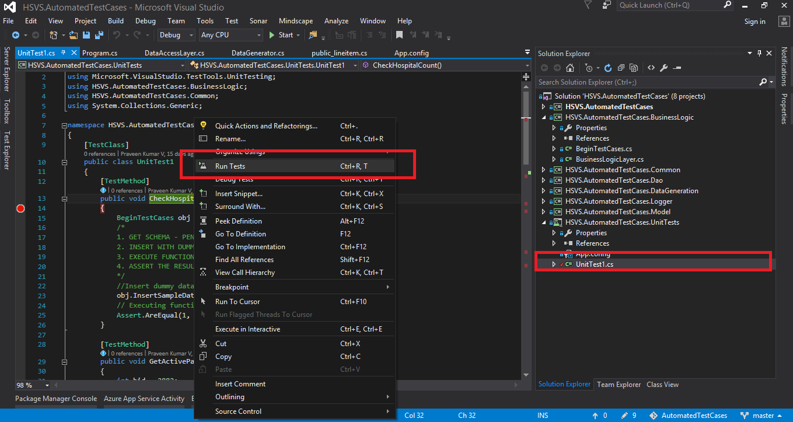

Description:
The overall idea is to insert dummy data to mysample table and Assert the count of the inserted data is 1(one).
obj.InsertSampleData(1, "Praveen", "999999999");

Assert.AreEqual(1, obj.GetSampleTableDataCount());

